The Amazing Bridges:

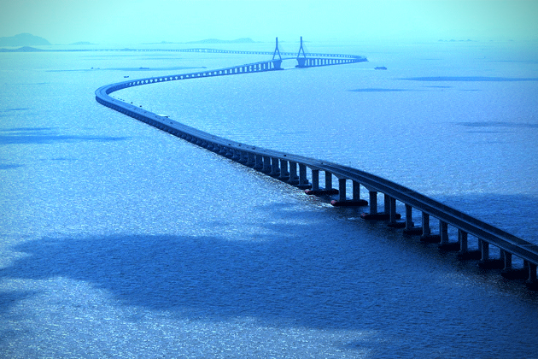

**MILLENIUM BRIDGE, LONDON**

Across from the Tate Modern, the bridge for the new millenium became known as The Wobbly Bridge shortly after it opened due to a quease-inducing wobble. It was closed for two years to undergo wobble removal. It is perhaps best known now for collapsing at the hands of Death Eaters in the movie version of Harry Potter and The Half-Blood Prince.

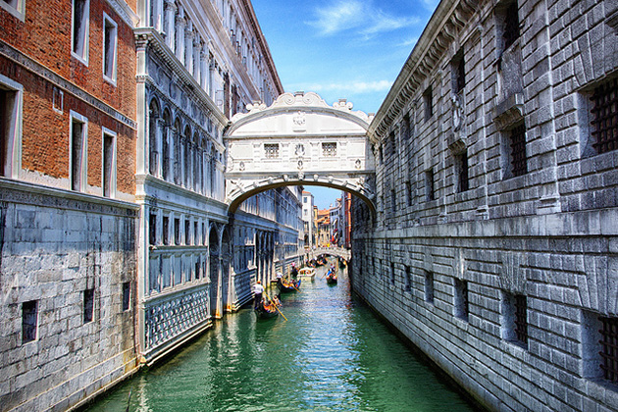

## BRIDGE OF SIGHS, VENICE, ITALY

## The Bridge of Sighs passes over the Rio di Palazzo in Venice and connects the holding facility known as the New Prison with the Doge’s Palace. The poet Lord Byron came up with the name, taking it from the legend that prisoners would sigh as they took in their last view of Venice before being locked up. Today, the palace is an art museum. Tomorrow, who knows?

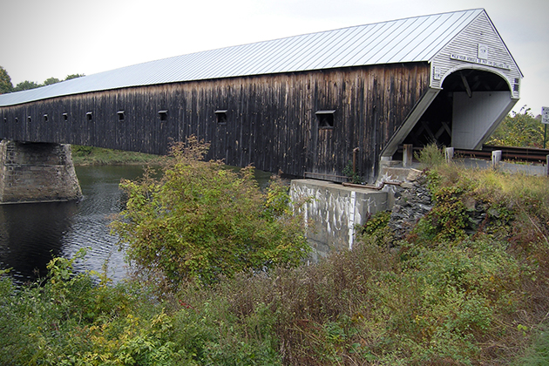

## CORNISH WINDSOR COVERED BRIDGE, NEW HAMPSHIRE

## The covered bridge that crosses the Connecticut River between Cornish, New Hampshire and Windsor, Vermont looks like a garden shed that’s been tortured on a rack in a Spanish dungeon. It still has the longest single covered span that carries motorized traffic, but the Smolen-Gulf Bridge in Ohio is longer overall.